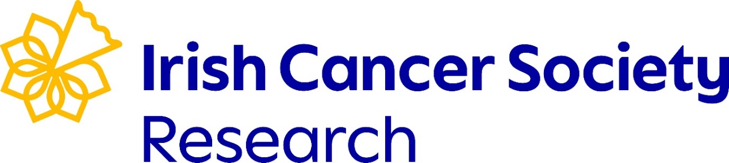

HRCI-HRB Joint Funding Scheme 2025
Expression of Interest
Please email this form to grants@irishcancer.ie by 3pm, Wednesday 3rd September with the subject line “EOI_FirstName_LastName” in PDF format.
Project Title:
(max. 50 words)
5 Keywords: | 1.  2.  3.  4.  5.
Project Duration:
(months)
Proposed Start Date:
Total Budget Requested (€):

Lead Applicant Details | Title:  Name:  Department:  Institution:  Email address:  Mobile:
Co-Applicant Details  Please copy and paste this row if needed | Title:  Name:  Department:  Institution:  Email address:
Collaborator Details  Please copy and paste this row if needed | Title:  Name:  Department:  Institution:  Email address:

Scientific Abstract:
(max. 200 words)
Plain English Abstract:
(max. 200 words)

What is the strategic priority/ priorities that this project is addressing?
Please refer to the ‘Theme and Eligibility’ section of the open call webpage
(max. 200 words)
Please include project background, methods (novel and/ or conventional) and references
(max. 300 words where references are excluded from word count)
We will not accept applications which do not include PPI
Please describe the PPI and what value this will add to the project
(max. 300 words)
What is the potential impact of the research?
We consider value from the perspective of people affected by cancer (nationally and internationally) alongside the impact on academia, science and research (max. 300 words)

Proposed Budget (€):  This can be changed at full application stage.  *PPI min. total costs should be €3,000 – please ensure the indicative costs reflect the PPI work | Category Year 1 Year 2 Year 3 Total  Personnel  Running Costs  Dissemination  PPI*  Overall Total Costs

