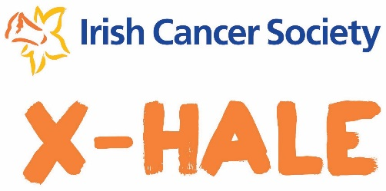
X-HALE Screening Sample Press Release

HEADLINE: E.G. (Your Youth Group Name) LAUNCH SMOKING PREVENTION SHORT FILM AT SCREENING IN (Screening Venue)

MOST IMPORTANT INFORMATION FIRST.
DATE: XX are due to launch a short film they made about the danger of smoking at a special screening in XXX.

DESCRIBE THE EVENT BACKGROUND DETAILS HERE.
The film was made as part of the Irish Cancer Society’s X-HALE 2020 Short Film Competition. The initiative supports youth groups to spread the word about the dangers of smoking online and in their community by creating a short film that encourages young people to be smoke free.

WHY THE PRESS RELEASE.
The group are holding the screening to promote their film and ask the local community to support their campaign by watching and sharing their film online at www.cancer.ie/xhale2020. The group with the most views will win an award at the X-HALE Youth Awards national event in July.

QUOTE
Quote from someone involved in the project here (Use quotation marks):
E.G. Group member, Joe Smith said, “It has been great to be involved in X-HALE as we have learned so much about the dangers of smoking and we can tell other young people why they should be smoke free through our film.”

Further quote if required.

CALL TO ACTION
This is where you give all the details of the event, plus contact details/website/email address if necessary.
E.G. The screening will kick off at 7pm on XX in XX. For further information go to XX Facebook’s page, or to watch and share the film, go to www.cancer.ie/xhale2020.

ENDS

CONTACT:
Contact details if the paper/radio station has any further questions or wants to organise an interview.

