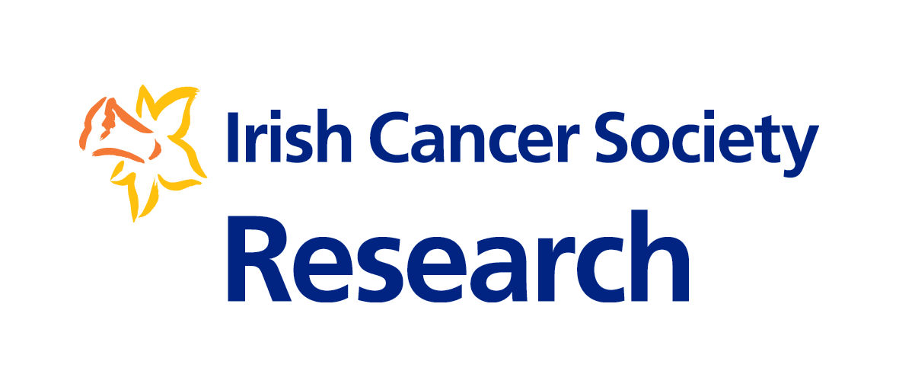
General Guidelines for Applicants

An Award to Examine the Barriers to Cancer Services for Socially Excluded Groups
(Underrepresented Communities Scoping Award 2021)

Frequently Asked Questions
Updated 10.09.2021

Who Can Apply?

- Do I need to have obtained a PhD to apply?
Not necessarily. You must have a PhD or PhD equivalent research experience.

- What is equivalent to a PhD?
Here, PhD equivalence is defined as three or more senior (first, joint-first, or last) author publications in peer-reviewed academic journals or 4 years full time research experience. Alternative research outputs may be considered eligible e.g., monographs. In such instances, candidates should contact grants@irishcancer.ie before applying.

- In terms of post-doctoral research experience, should I consider the date in which I submitted my doctoral thesis or the date in which I graduated with my doctoral degree when calculating my research experience.
Applicants must calculate your research experience based on the submission date for your PhD thesis.
- Why is a PhD or PhD equivalent required for nurses and allied health professionals?
Obtaining a PhD suggests that a minimum standard of research capability has been met. A ‘PhD by publication’ is offered by some higher education institutes in which a collection of peer-reviewed publications is sufficient to award the PhD degree. Three first-author publications are most often cited as the minimum standard. Therefore, for the purpose of this award, three first-author publications is considered equivalent to a PhD for nurses and allied health professionals. Alternatively, nurses and allied health professionals may have four years full time research experience.

- Can medical doctors apply for the Underrepresented Communities Scoping Award?
Yes, provided you have a PhD (or equivalent).

- Can I apply for the Underrepresented Communities Scoping Award if I have just completed my PhD?
In order to apply, applicants must have at least two years research experience since the submission date of their PhD thesis. If you are unsure of your eligibility, please contact grants@irishcancer.ie.

- Are non-Irish citizens living in Ireland eligible to apply?
Yes, if you are a non-Irish citizen but are eligible to work in Ireland, and you meet the eligibility criteria, you can apply for the Underrepresented Communities Scoping Award.

- Can more than one person apply on the same grant?
Yes. For this award any group members will be considered as co-applicants (maximum of 5 co-applicants plus 1 lead applicant). Co-applicants must have a well-defined and substantial role in the proposed plan and must hold a contract that covers the duration of the award. Details of any additional research team members can be included in the application form.

- Can I apply to study abroad, such as in the USA?
No, funding is only available for research being conducted in the Republic of Ireland.

The proposed project

- My project uses qualitative methods only; can I apply for the Underrepresented Communities Scoping Award?
Unfortunately, no. Quantitative methods are necessary to answer the required research questions. However, a combination of both quantitative and qualitative research is also acceptable

- My project will directly answer all the desired research questions but not the required research questions, can I still apply?
Unfortunately, no. You are required to answer the required questions.

- My research project will focus on a specific underrepresented community, can I still apply?
Unfortunately, no. The research must primarily focus all underrepresented communities and socially excluded individuals.

Institutions

- Can I only apply for funding at an Irish host institution?
Yes, funding is only available for research to be undertaken at host institutions in the Republic of Ireland.

- Are universities in Northern Ireland eligible for the Underrepresented Communities Scoping Award?
The Underrepresented Communities Scoping Award is tenable only for individuals who intend to carry out their research at host institutions in the Republic of Ireland. This is because the money raised for the Irish Cancer Society to fund cancer research is raised in the Republic of Ireland.

Mentor

- Can a principal investigator be a mentor to more than one Underrepresented Communities Scoping Award applicant?
Yes, a principal investigator can mentor more than one applicant.

- Do you have to be a permanent member of staff in order to be a Mentor?
A Mentor must hold a post either permanent or on contract basis that covers the duration of the award period.

- Can my mentor be based outside of Ireland?
No, it would be important to have a mentor that is embedded within the host institution or research site. International advisors may be included in your application and details of this could be included as part of your project summary

- I have 4 years of post-doctoral experience, do I need to include a mentor?
No. A mentor is only required for lead applicants with fewer than 4 years post-doctoral research experience. If the application is submitted as a group and neither the lead applicant nor the co-applicants have 4 years of post-PhD research experience then a mentor is required.

Funding

- Is there an overall limit to the amount of funding awarded?
Yes, the maximum funding granted for the Underrepresented Communities Scoping Award is €50,000 over 12 months.

- Can the grant be used to pay for my salary costs?
Yes, you can use the funding to cover your salary costs.

- Can the grant be used to pay for equipment?
Yes. However, the grant can only be used to fund small equipment vital to the completion of the project. Large equipment, or equipment which constitutes infrastructure for the host or data collection institute will not be funded. Ultimately, the Irish Cancer Society retains the right to reject any equipment costs included in proposed budgets.

- Can the grant be used to employ staff?
Staff, such as research assistants, would need to be sufficiently justified within the remit of the Underrepresented Communities Scoping Award. We recommend that you contact grants@irishcancer.ie to discuss allocation of budget to staff before applying.

- Can the grant be used to fund a Masters student?
No, the grant cannot be used to fund a Masters student.

Number of Awards

- How many Underrepresented Communities Scoping Awards are available?
There is funding available for one award in 2021.

Commencement of Project

- When do successful projects commence?
The successful projects will not begin earlier that December 2021.

Application deadlines and dates

- When do applications need to be in by?
Applications must be submitted online through Gateway Grant Tracker by 3pm Monday 11th October 2021.

- Do co-applicants have to approve the application by the deadline?
No, but Co-applicants must confirm participation in the application.

- Do mentors have to approve the application by the deadline?
Yes. For lead applicants with less than 4 years of post-doctoral experience, the mentor will have final signatory approval. Your mentor must approve the application by this deadline. It is the responsibility of the lead applicant to ensure that their application is approved by all co-applicants and the mentor before the deadline. Please ensure that the application is submitted with sufficient time allowed for final approval by the mentor.

The Application Process

- What budget details are required for the Application?
In the Application you will need to give details of Salary, Consumables, Equipment, Travel/Dissemination, and PPI costs (optional). For salaries, applicants will be referred to the Irish University Association's (IUA) salary scale. Your years’ experience will determine your point on the salary scale.

- How important is the societal considerations section?
The Patient Panel will appraise and give feedback on the societal considerations section. The scientific reviewers will not be assessing any of the patient review sections, and vice versa. As such, it is vital that the sections reviewed by patient representatives are written in accessible plain English. Failure to do this may result in the patient representatives not being able to accurately understand these sections of your application

How will proposals be assessed?

- Who will review my application?
Applications go through a number of review steps. In the first instance, the Research Team at the Irish Cancer Society will check applications to ensure they meet eligibility criteria. Eligible applications are then sent for external review. The review will be conducted by international scientific reviewers. The application will also be appraised by patient representatives.

- Will scientific and patient reviewers assess the same sections?
No. Scientific reviewers will assess the Applicants’ CVs, Mentor, Co-applicants and research team, and Research Programme. Patient reviewers, conversely, will appraise the following sections: Project summary, Sharing of Research Findings, and Public and Patient Involvement. The scores from each reviewer will then be combined.
Both scientific and patient reviewers will be asked to appraise the Budget section for feasibility.

